

ResumEmphasizer

Resumes with Impact: Creating Strong Bullet Points

2022 August 12

Julia, Leo, Hailey, JiHee

People space

CA

**Table of Contents**

1. **Introduction**
2. Problems
3. Solutions
4. Business Model Canvas
5. Target Audience
6. **Overall description**

1) Key Technologies

2) Key Features

3) Flow Chart

4) Pricing

1. **Specific requirements**
2. Wireframe
3. Annotation Standard
4. Training Result
5. **Complementary Point**

1) Website

2) spaCy

1. **Introduction**
2. **Problems**

Creating a clear and concise resume with phrases and keywords to pass through HR filters is hard. Even when a job applicant has a right experience, without the right keywords and phrases in the resume the applicant can be filtered in the hiring process. Within these problems, we want to create an AI Resume Writer that will match keywords and phrases with the perspective of company job description.

1. **Solutions**

We use AI trained by developers to find bullet points in your resume. AI extracts the requirements from the job description and corresponds them to the ones on your resume. This refines your resume and eventually achieves our final goal of passing the HR filter.

1. **Business Model Canvas**

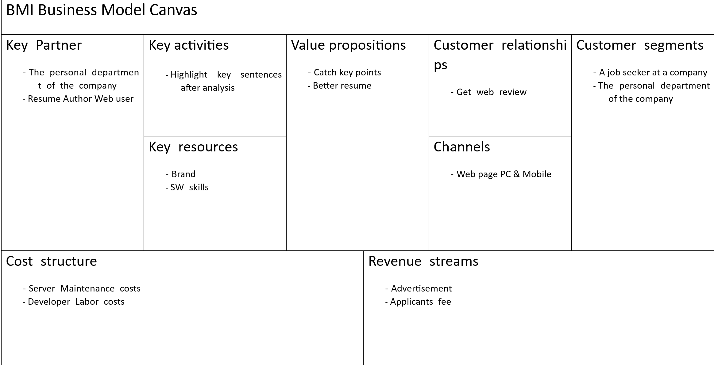

1. **Target Audience**

ResumEmphasizer targets prospective college graduates or social beginners who are new to or difficult to write resumes. They are not sure what they wrote on their resumes meets the company's requirements.

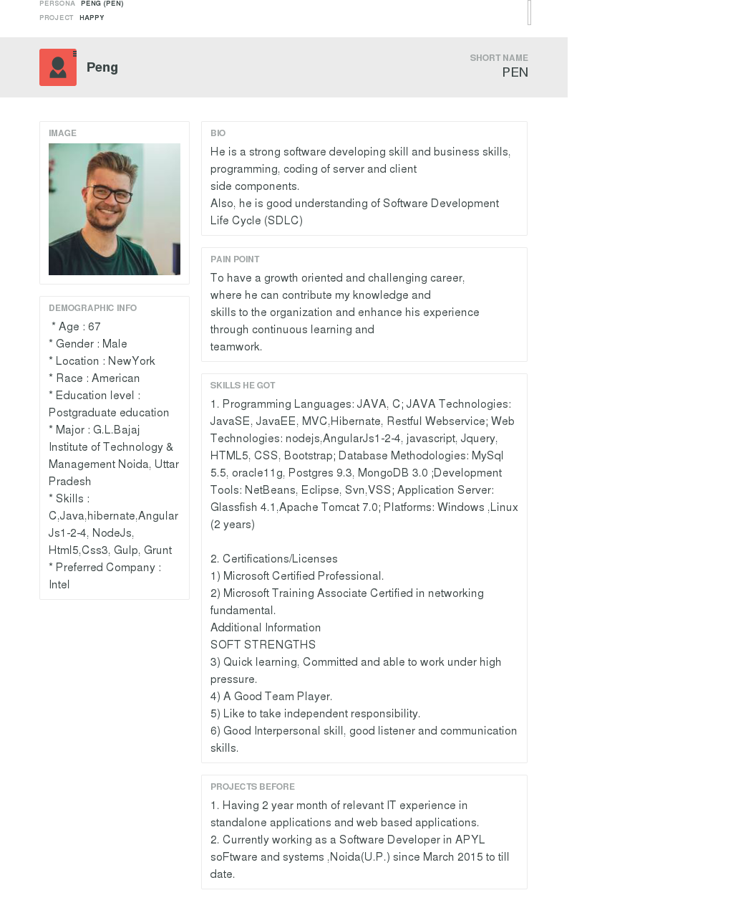

|  |  |
| --- | --- |
|  |  |
|  |  |

1. **Overall description**

(Git hub: [**https://github.com/hyun-hyang/ResumEmphasizer**](https://github.com/hyun-hyang/ResumEmphasizer)**)**

1. **Key Technology**

* Design websites with ***wordpress***.
* Annotate datas with ***doccano***.
* Train AI model with ***spaCy***.

1. **Key Features**

* Find bullet points
* Scoring your resumes
* Passing HR Filters

1. **Pricing** [**http://44.227.122.114/pricing/**](http://44.227.122.114/pricing/)

We have a two-track pricing plans : Plan 1 & Plan 2

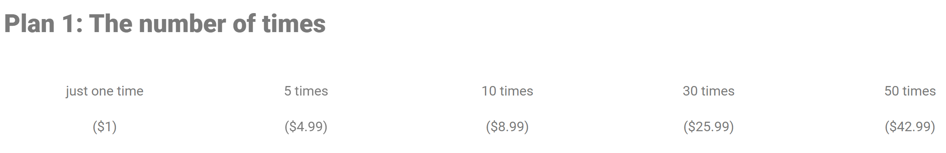

($ per trial : 1 / 0.998 / 0.899 / 0.866 / 0.859 )

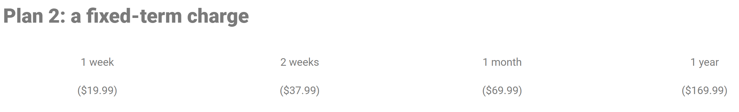

($ per day : 2.85 / 2.71 / 2.3 / 0.46 )

***Free Trials*** : You can get 3-free-trials when you create an account. You can also get 1-free-trial each for both you and your friend when you invite friend.

1. **Flow Chart**

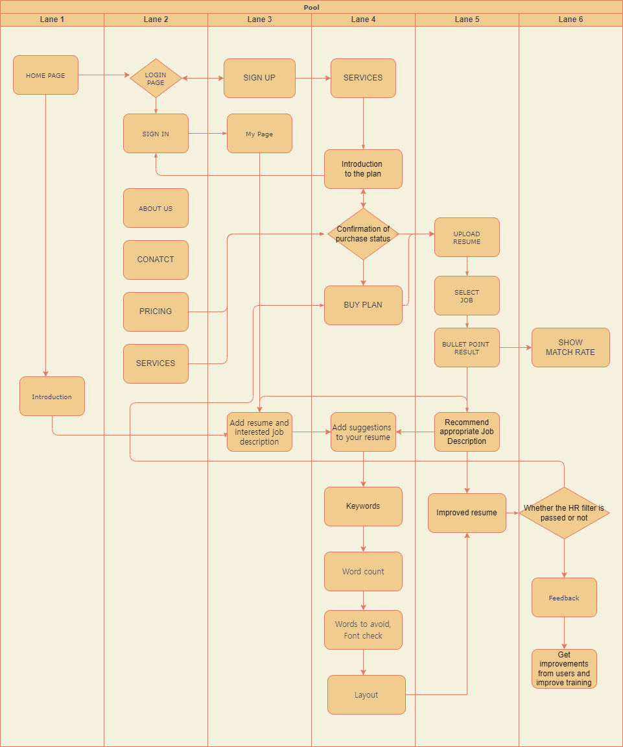

1. **Specific description**
2. [**Wireframe**](https://xd.adobe.com/view/4887e308-af02-43a4-b70e-07b2c0bbb3e7-1dd4/)

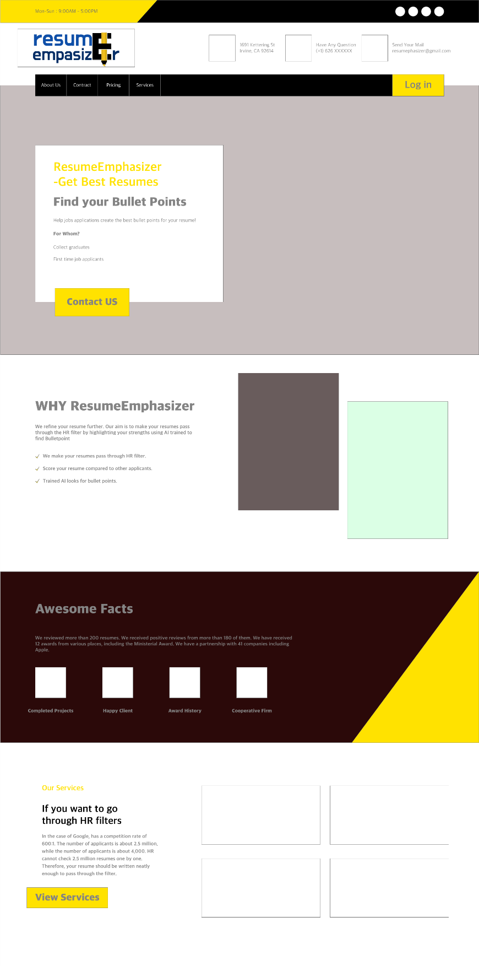

<Landing page>

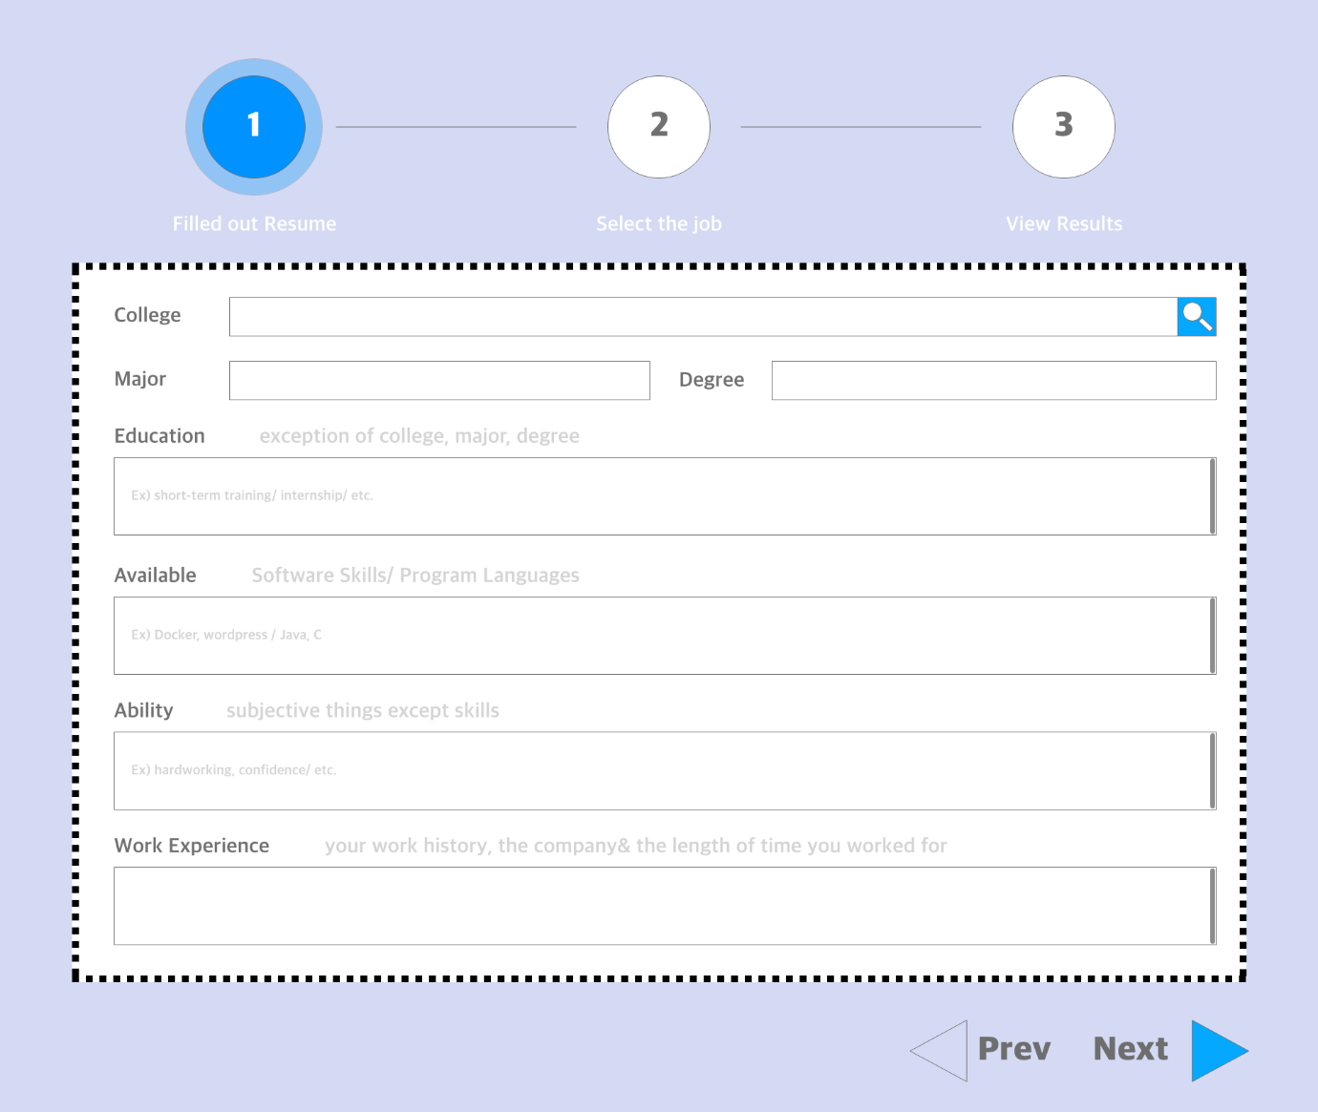

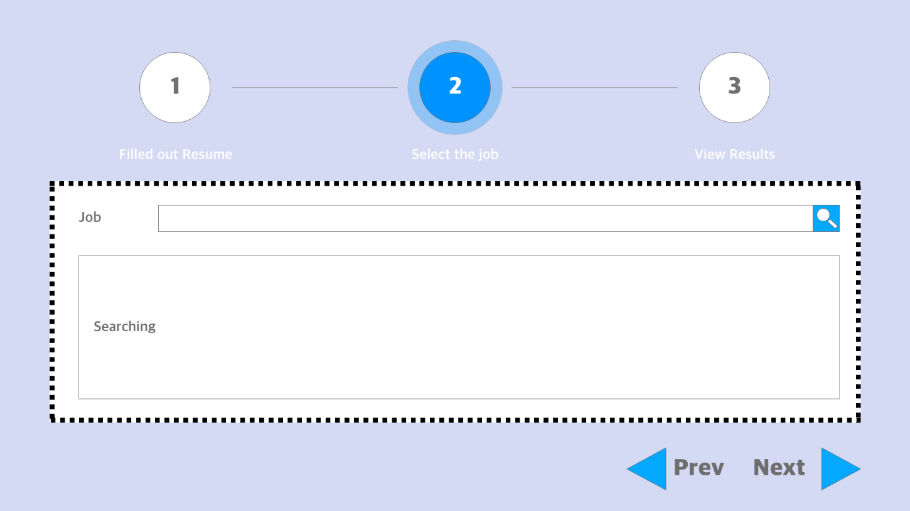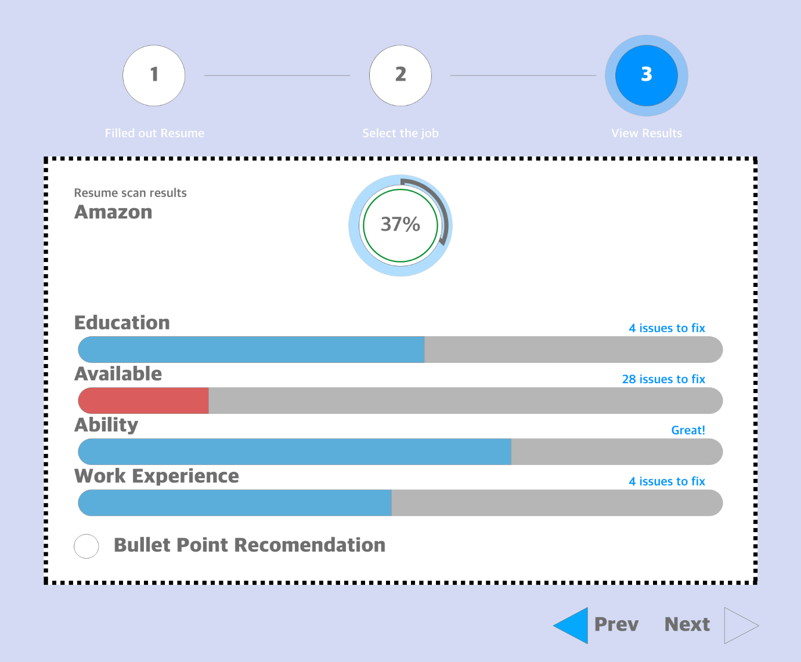

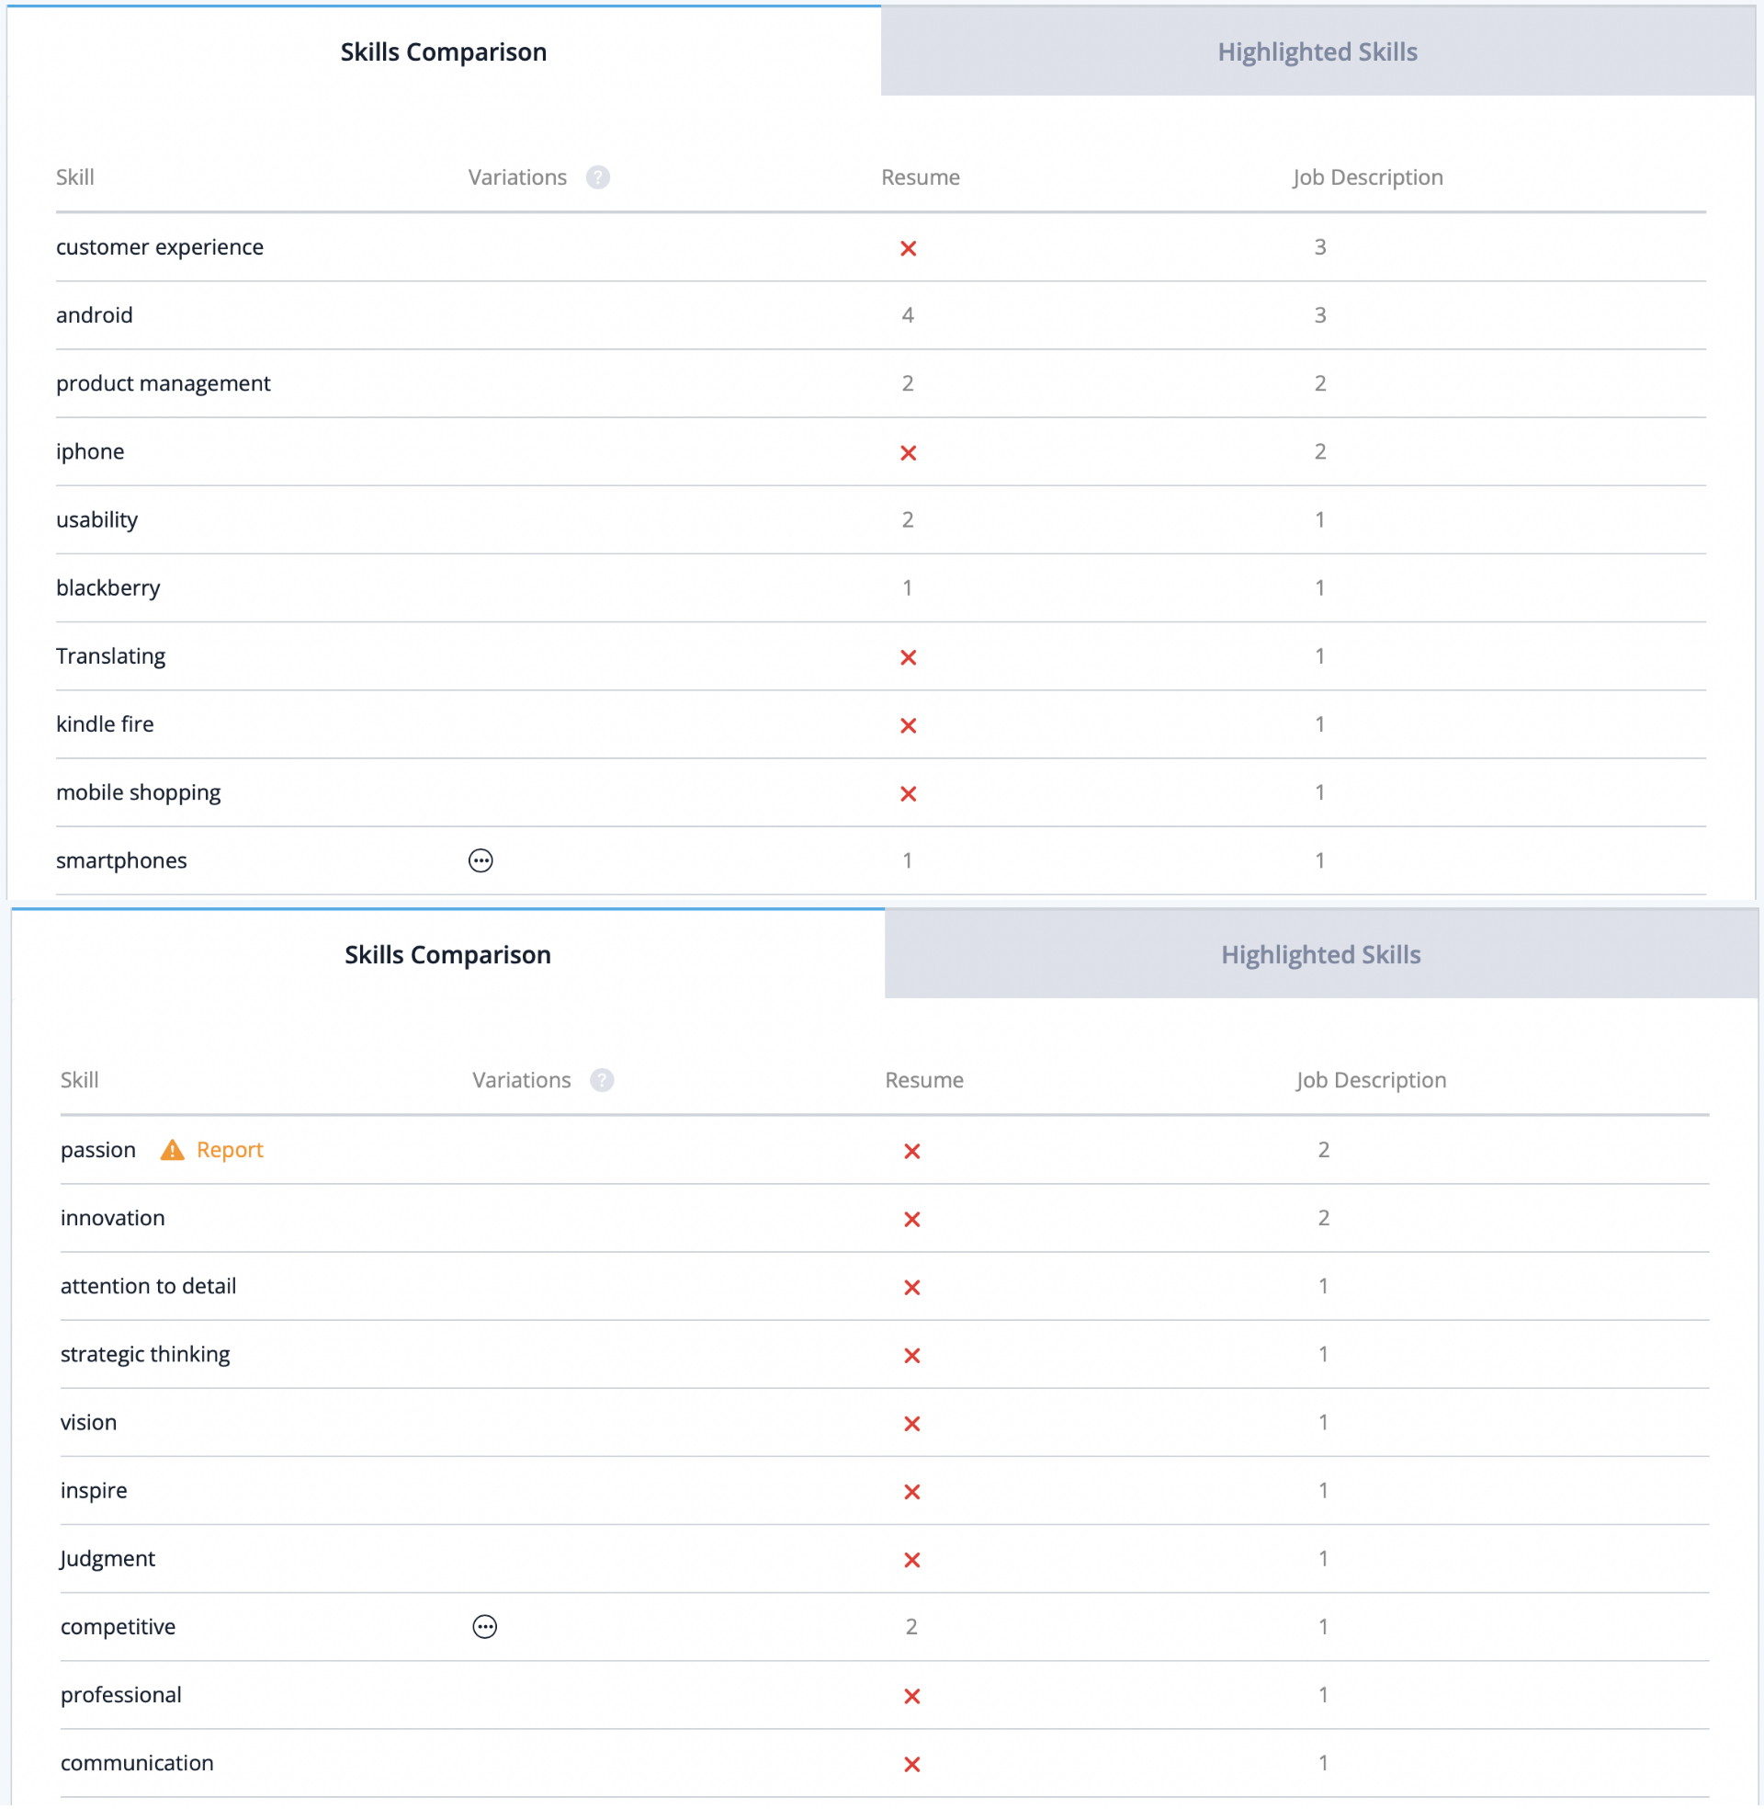

1. **Web Site** <http://44.227.122.114/>
2. **Promotion Video** [**https://www.youtube.com/watch?v=syONP3HIYIE**](https://www.youtube.com/watch?v=syONP3HIYIE)

**[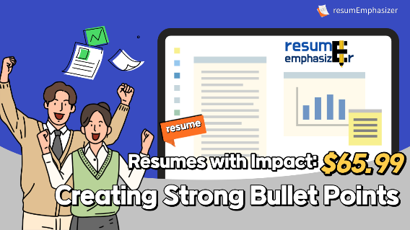](https://www.youtube.com/watch?v=syONP3HIYIE)**

1. **Annotation Standard**

We gave different labels to resume and job description for annotate. First, we used the labels of work experience, skill, college, major, education, useful, award, age, and degree for resume. Work experience covers the companies, projects, and so on. Skill means specific abilities such as Java Python, while ability means subjective abilities such as challenging and good communication.  
Secondly, we used company, project, job, required skills, preferred skills, department, benefit, required year for job description. Benefit here means company welfare. By separating required skills and preferred skills, we tried to obtain the accurate image of qualified employee of company.

​

1. **Training Result**

* **resume**

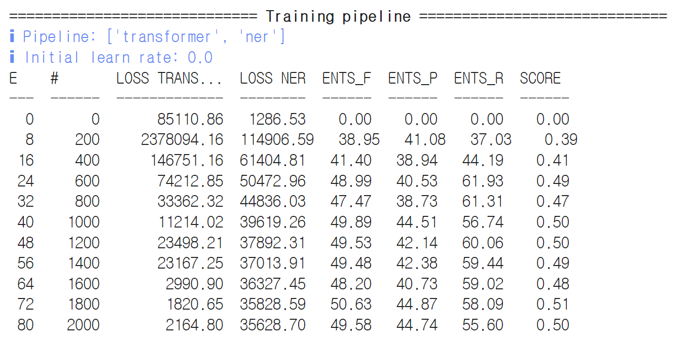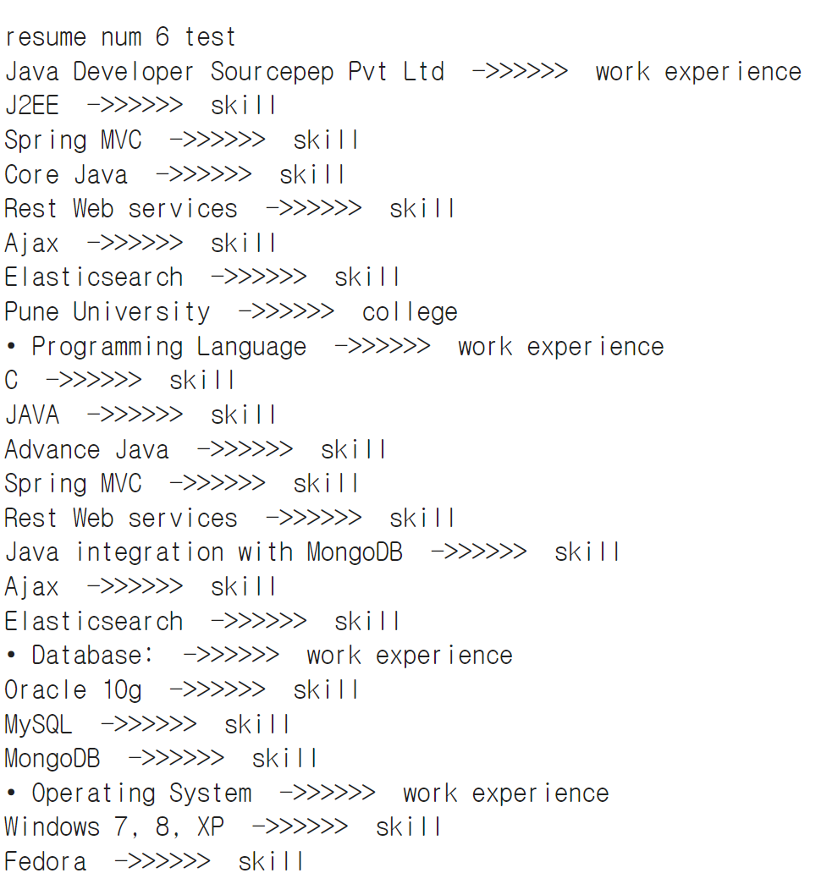

<resume.ipynb>

* **job description**

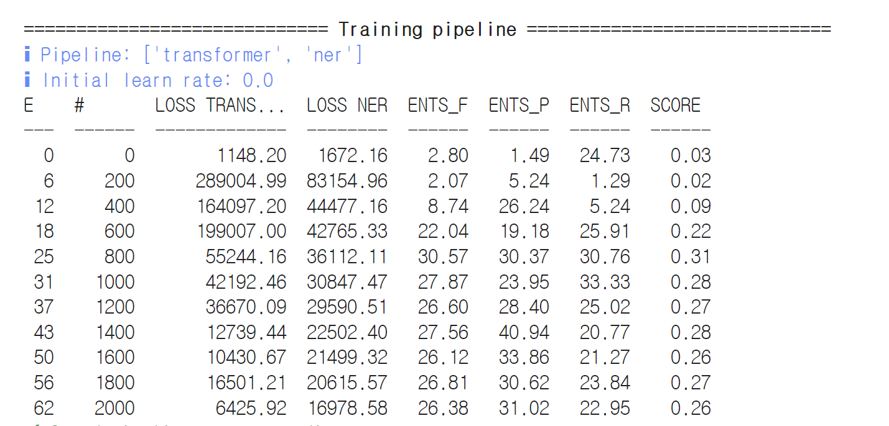

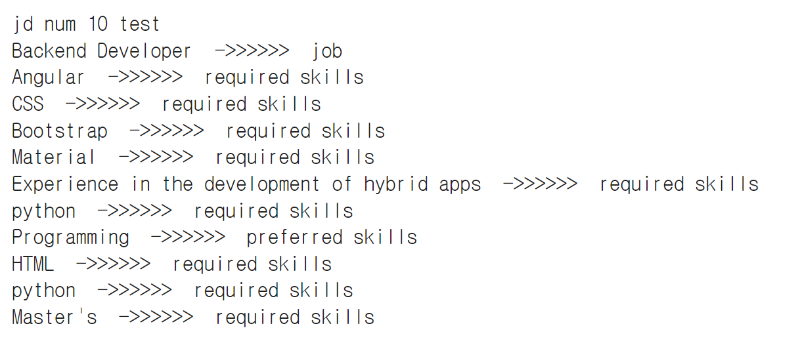

<jd.ipynb>

1. **Complementary Point**
2. **Website**

We are not yet at the completion stage in implementing the web page. For example, if you upload your resume on a web page, AI should review it, but spaCy and the site have not yet been linked. In addition, according to the Business model canvas, advertising was expected to be the main source of income, but the advertising function was not implemented.

1. **spaCy**

We trained about 150 resume and 150 job descriptions we annotated on spaCy, which are insufficient in quantity and inaccurate in annotate, resulting in occasional inappropriate learning results. In addition, there is a regret that more accurate results would come out if the label was further subdivided.

We had to match resume and job description with a spaCy-trained model, but we are still in the unfinished stage. Furthermore, we should have implemented unique features that other companies do not have, such as measuring the score of resumes, but we are still in the unfinished stage.